Step #1: Students are tasked with designing an alarm that informs the user when the current drawn by a load Rl (Il) exceeds the nominal value of 50mA by 10% or more.

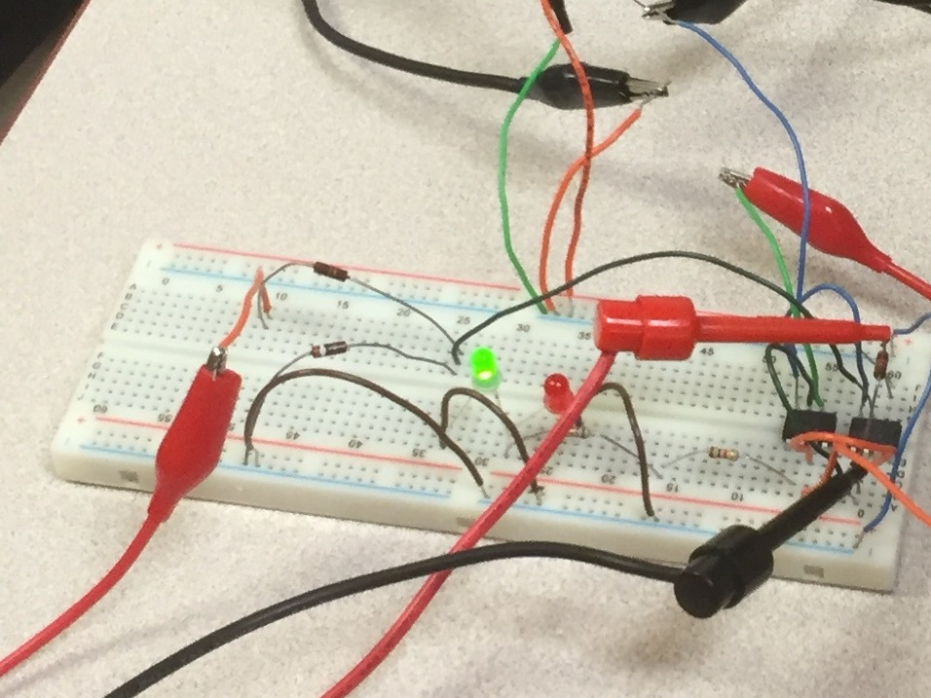

Step #2: Ideally, a measurement device should have no effect on the system, which it observes. Why is it important, to properly measure load current drawn, that Rm << Rl ?

If Rm were of the same order of magnitude as the value of Rl then it would decrease the current drawn to the load substantially and result in an inaccurate and therefore useless measurement.

Step #3: Calculate the nominal load resistance (Rlnom) from the following values Vs =12V, Il=50 mA. Show work

Rl=(vs/Il)-Rm

Ri=(12/0.05)-0=240Ω

Step #4: Calculate the nominal power dissipation of the load resistance (plnom). Show all work.

Pl=(il)2 Rl=(50*10^(-3))2*240=0.6watts

Step #5: Design a circuit similar to the one presented in Figure1, to current drawn by the load (Il) and trigger one of the two LED’s as defined below.

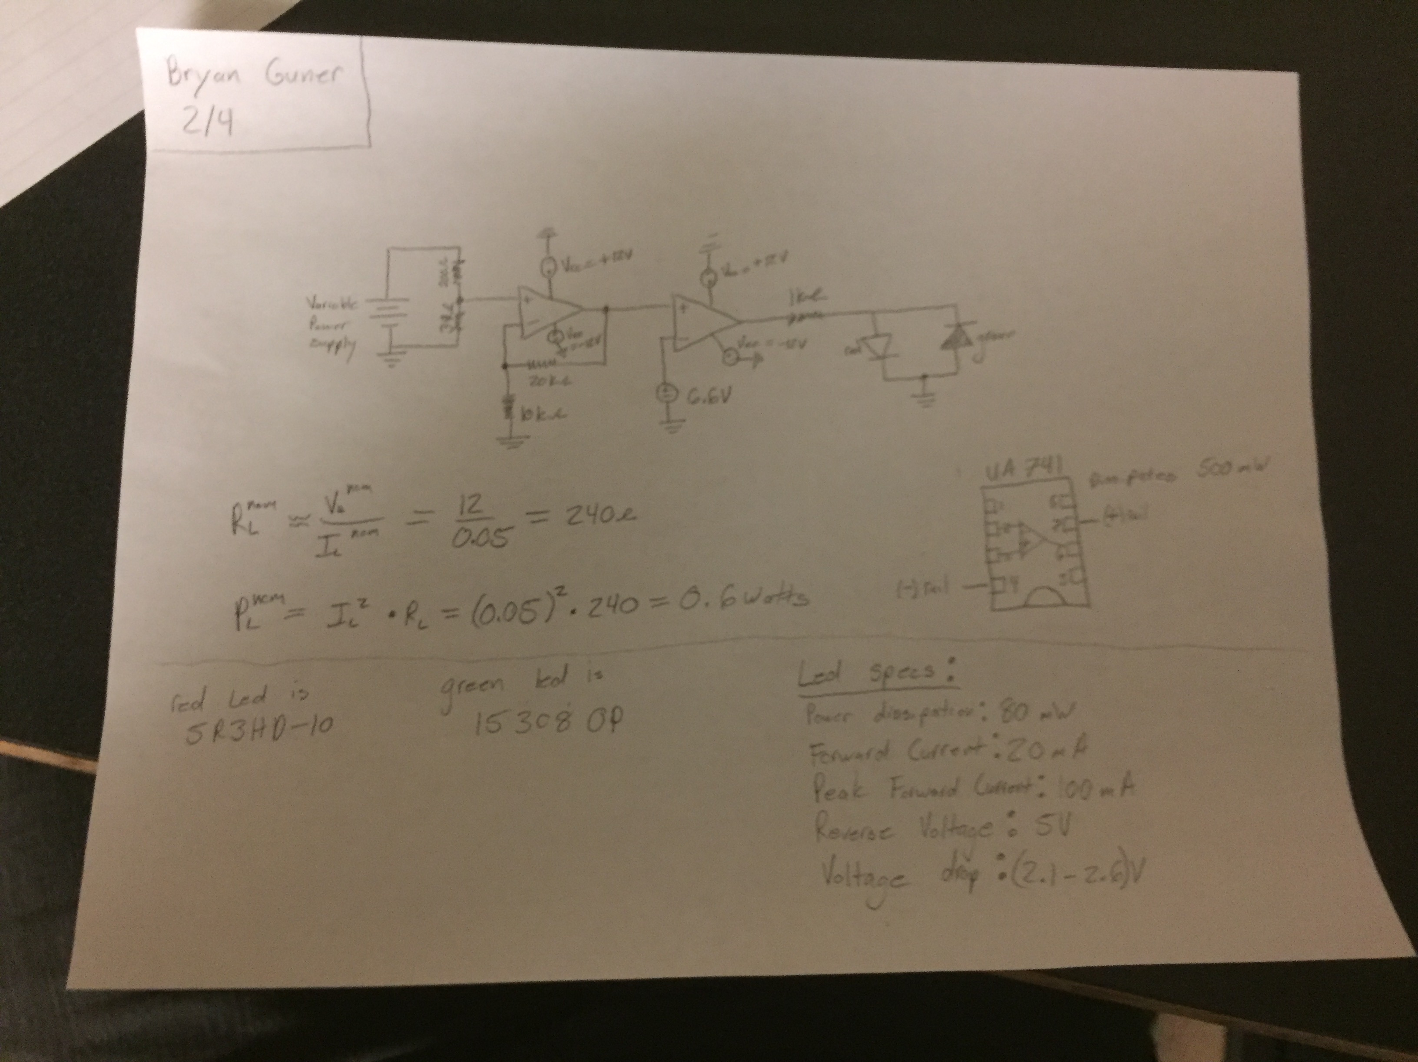

Step #6: Provide a sketch and a brief explanation of the design in the lab report. Define all parameters and component values.

The schematic above in (step #5) defines all component values, the parameters are

+15V dc if Il< 1.1* Ilnom

-15V dc if Il>1.1*Ilnom

Where Ilnom= 50 mA

A voltage gain of 2 on the first Amplifier circuit.

Voltage supplied to rails > output voltage of amplifiers.

R0=1000Ω

Rm<<Rl

Green LED fires if Il<It , Red LED fires if Il>It

Step #7: Why should the user be concerned with excessive current draw? Consider it’s affect on the appliance as well as the fuse in figure1.

Specifically relative to the appliance, if the current drawn is excessive, the condition Il>1.1*Ilnom is continuously satisfied and the alarm would always activate the Red LED. In general excessive current draw is responsible for destroying electrical devices either by short circuit or overheating. If excessive current draw occurred before either of the amplifier stages than the signal coming out of them would be saturated and the circuit would probably not preform it’s intended function.

Step #8:Construct an alarm circuit in Pspice. In the lab report include a screenshot of the schematic.

(NICK)

step #9:Preform a DC sweep simulation in Pspice. Source voltage should range from vs=6V dc to vs=18V dc. Include a graph demonstrating output voltage (vo) vs Load current (Il)

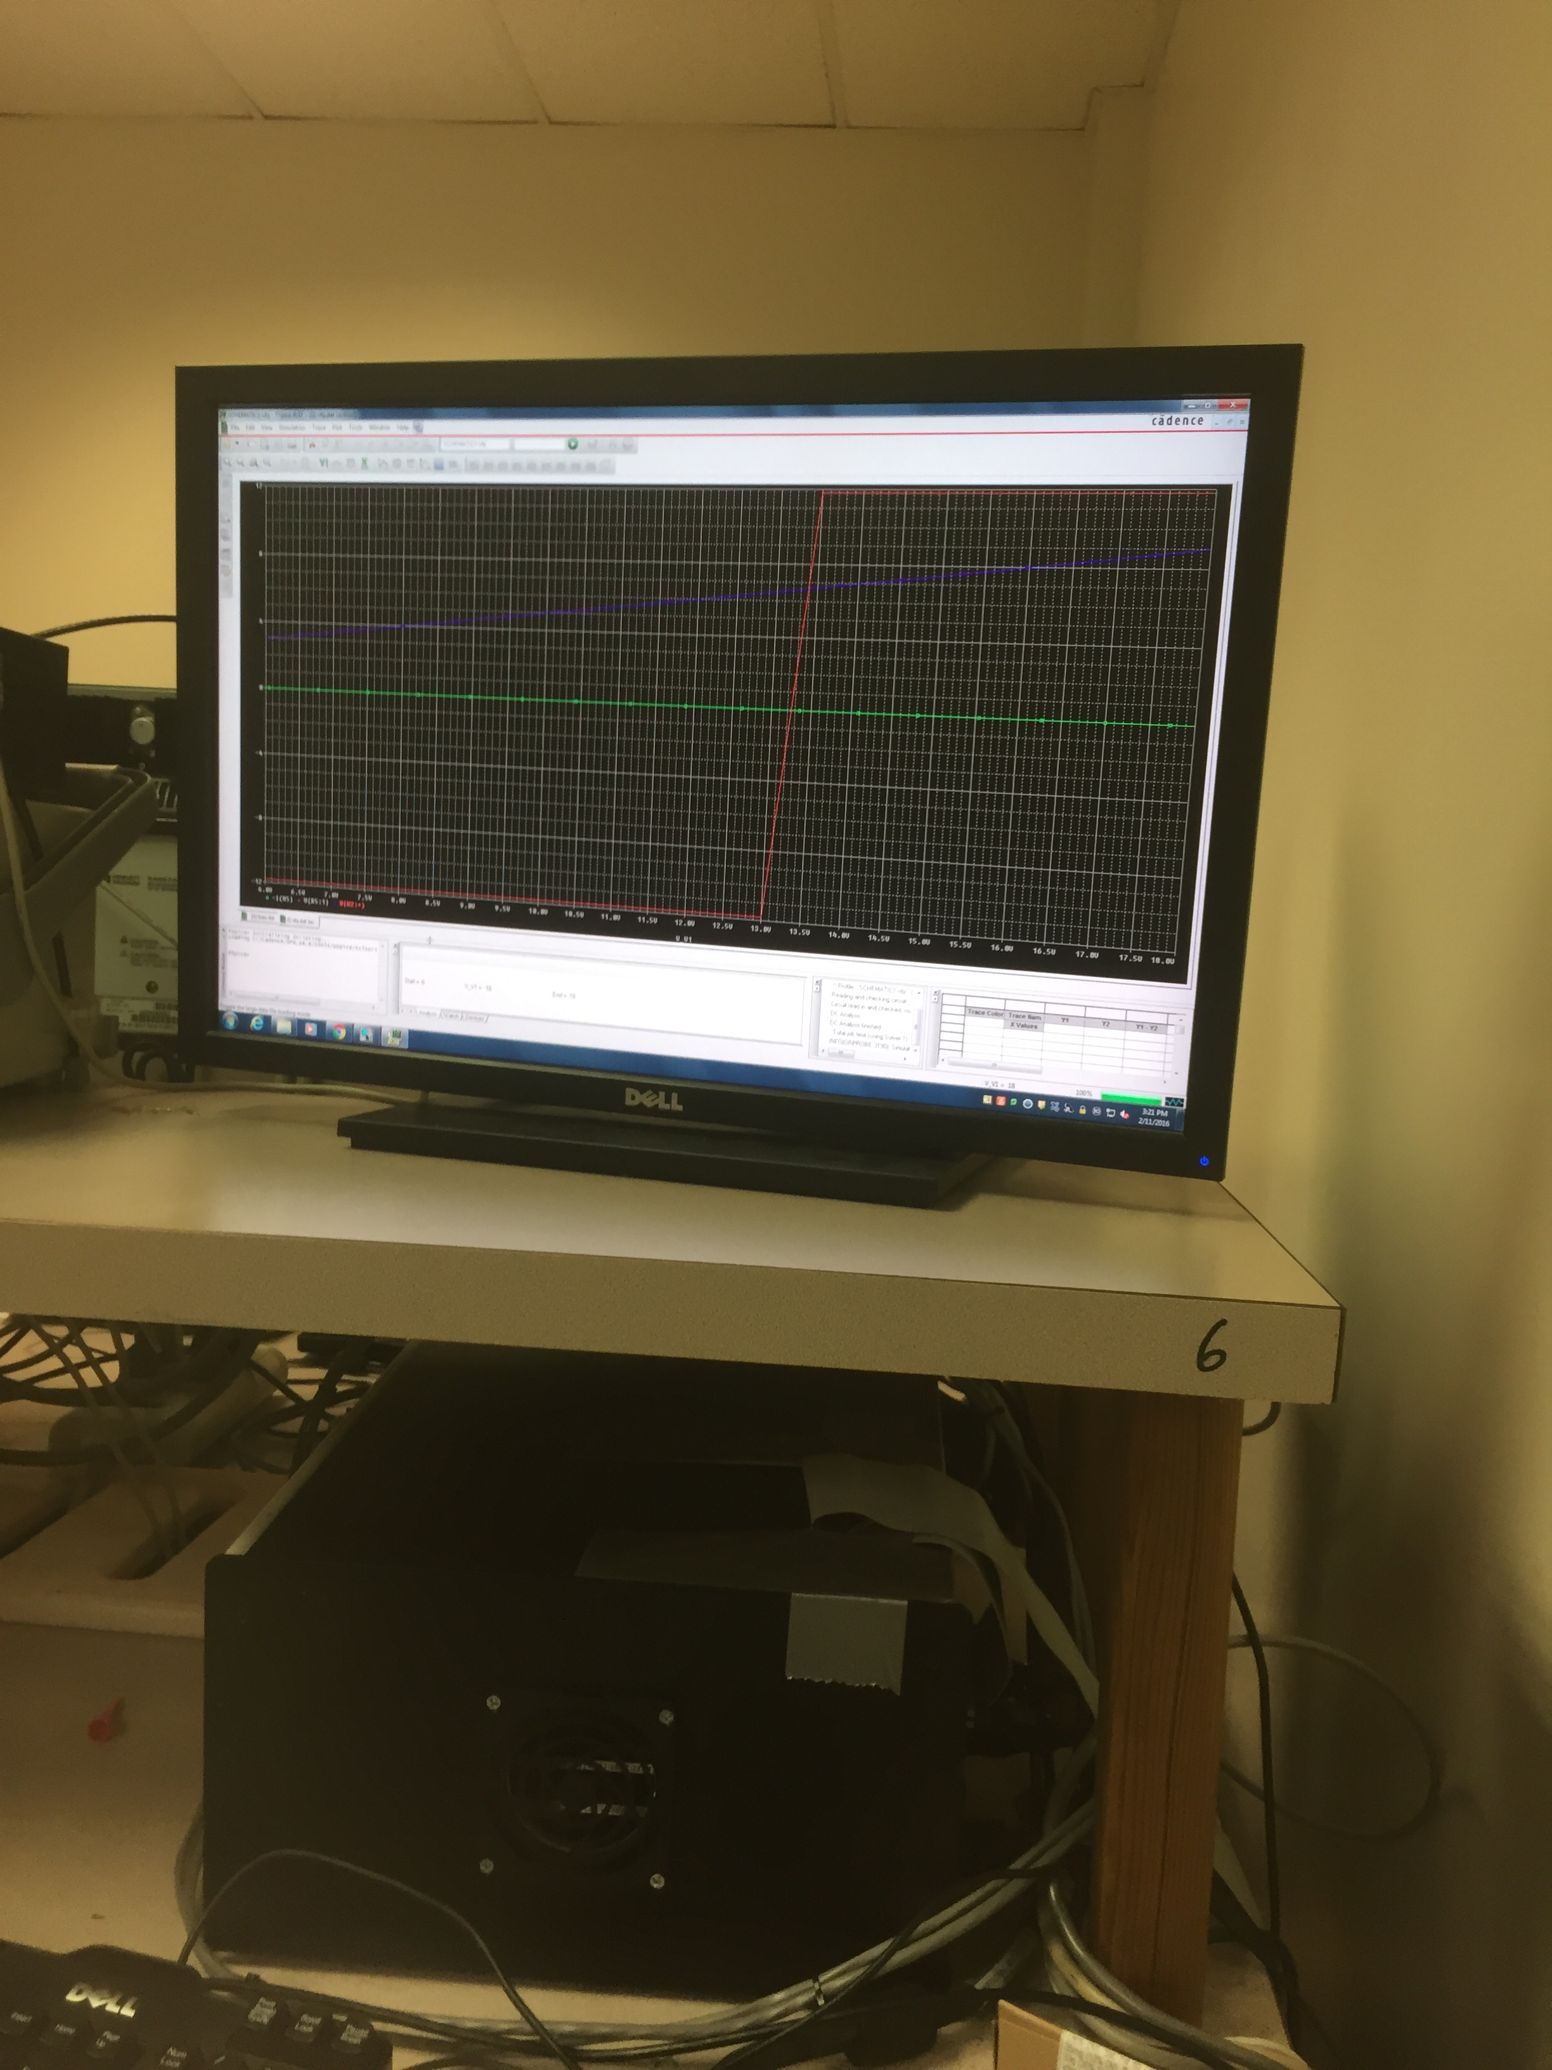

(Current =green , Input voltage =blue, Output voltage=red)

Step #10: Construct the circuit in hardware

(picture of circuit is listed in step #1)

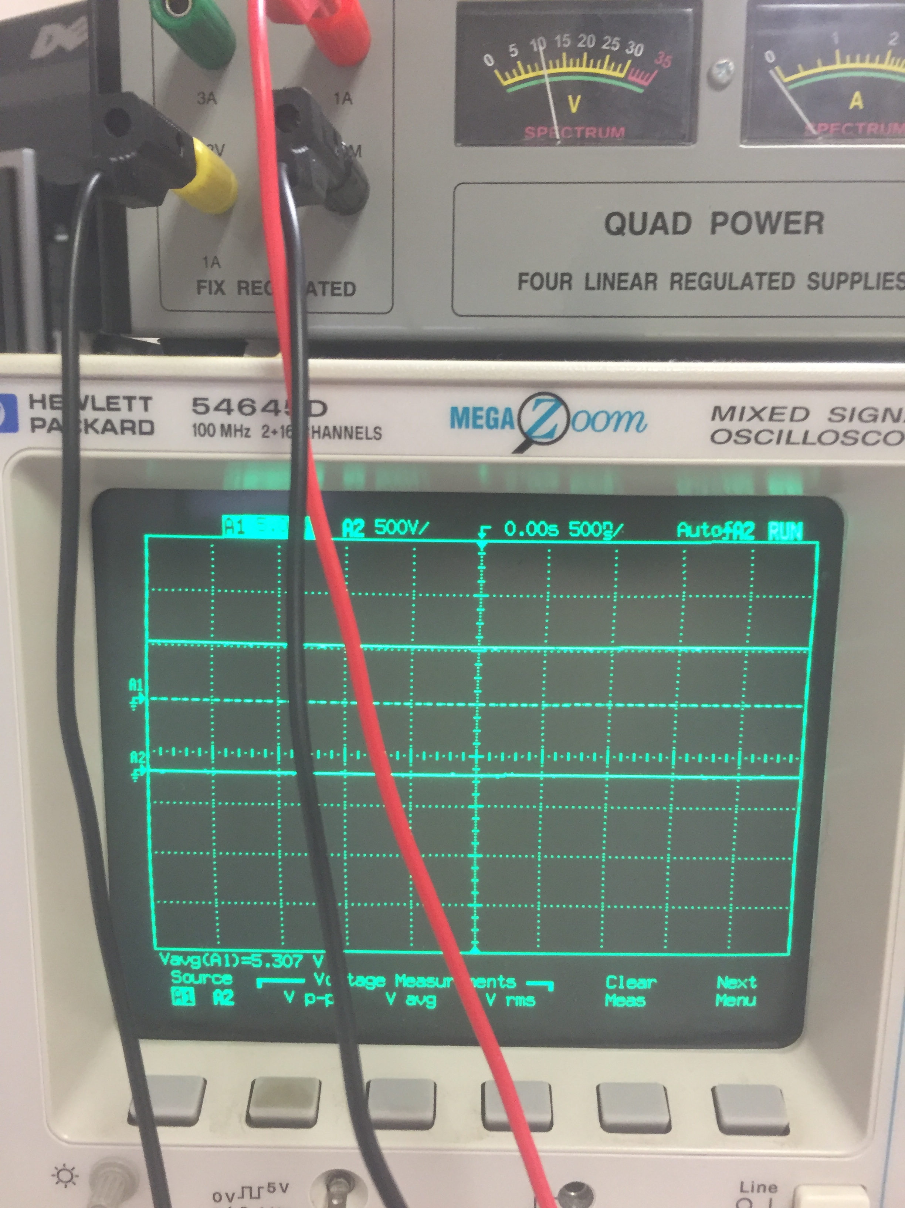

Step #11: In the lab report, include a picture of the hardware (taken via cellphone).

A picture of the breadboard LED alarm was provided under Step #1

Step #12: Test the circuit, complete the table below

|  |  |  |  |
| --- | --- | --- | --- |
| Observed load current (Il) | Load resistance (Rl) | Green LED status | Red LED status |
| Approx. 50mA | 1kΩ | on | off |
| Approx. 55mA | 1kΩ | on | off |
| Approx. 60mA | 1kΩ | off | on |

Step #13:How may the circuit be adapted to generate an alarm (aka red LED) when observed load current is either 10% above or below the nominal value?

Remove the green LED from the circuit and the second amplifier stage, replace the red LED with another non-directionally biased red led that acts as a diode that will be triggered from one end if the current is below the nominal value by more than 10% and triggered from the other end if the current exceeds the nominal value by 10%.

Step #14:

Calculate the error introduced by the measurement resistor:

Error=abs((Vlnom/Rlnom)-(Vlnom/(Rlnom+Rm)))/(Vlnom/Rlnom)=

abs((12/240)-(12/(200+39))/(50*10-3)=0.00418=.42%error